



Submitted by: Madan Lal

Instructor: Dr. Faheem Akhtar Rajput

**LAB # 03**

Sukkur IBA University, Nisar Ahmed Siddique Road, Sukkur

CMS ID: 053-18-0005

**Department of Computer Science**

Semester VI

**SIBAU**

**JAVA**

**Lab Tasks**

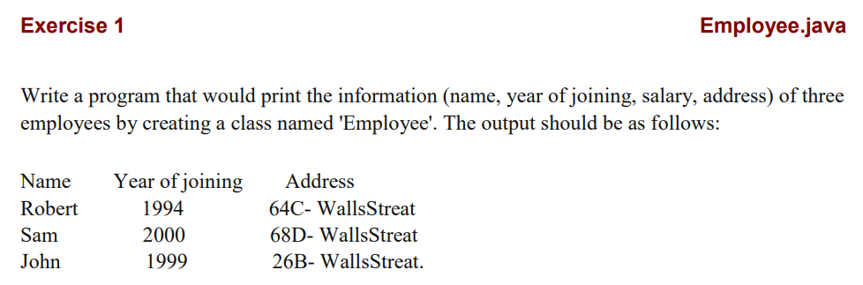

class Employee {

    public static void main(String args[])

    {

        System.out.println("Name\tYear of Joining\tSalary\tAddress");

        Display obj1 = new Display();

        obj1.Disp("Robert",1994,2900,"64C-WallsStreat");

        obj1.Disp("Sam",2000,2200,"68D-WallsStreat");

        obj1.Disp("John",1999,3100,"26B-WallsStreat");

    }

}

class Display {

    void Disp(String name,int year,int salary,String address) {

        System.out.println(name+"\t"+year+"\t\t"+salary+"\t"+address);

    }

}

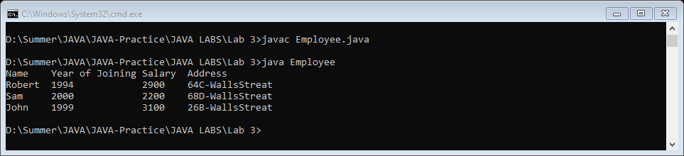

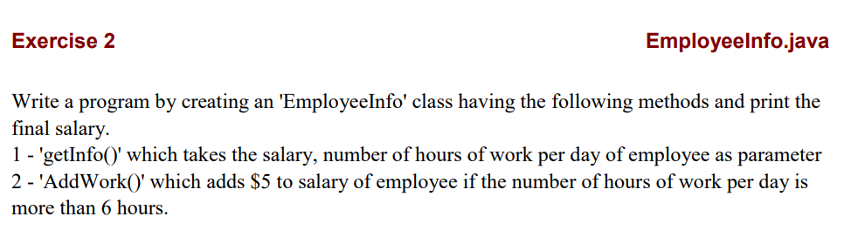

class Employee {

    public static void main(String args[])

    {

        EmployeeInfo obj1 = new EmployeeInfo();

        obj1.getInfo(2900,4);

        obj1.getInfo(2200,8);

        obj1.getInfo(3100,12);

    }

}

class EmployeeInfo {

    void getInfo(int salary,int hoursOfWork) {

        if(hoursOfWork>6)

        {

            int newSalary = AddWork(salary);

            System.out.println("Your New Salary is : "+newSalary);

        }

        else

        {

            System.out.println("Your Salary is : "+salary);

        }

    }

    int AddWork(int salary) {

        return salary+=5;

    }

}

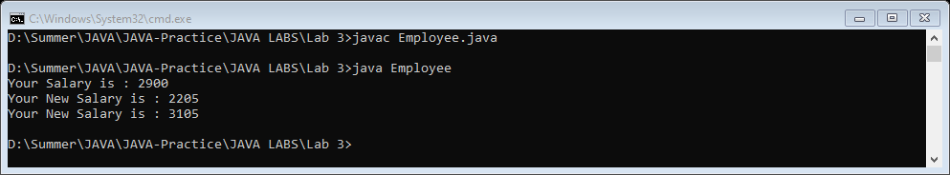

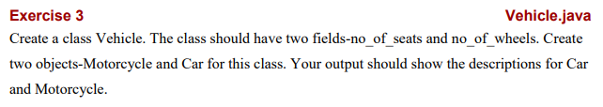

public class Vehicle {

    public static void Car(int no_of_seats, int no_of_wheels) {

        System.out.println("Number of Seats car: "+no_of_seats);

        System.out.println("Number of Wheels car: "+no_of_wheels);

    }

    public static void MotorCycle(int no_of_seats, int no_of_wheels) {

        System.out.println("Number of Seats bike: "+no_of_seats);

        System.out.println("Number of Wheels bike: "+no_of_wheels);

    }

    public static void main(String args[])

    {

        int no_of_seats  = 5;

        int no_of_wheels = 4;

        Car(no_of_seats,no_of_wheels);

        int _no_of_seats  = 2;

        int _no_of_wheels = 2;

        MotorCycle(_no_of_seats,_no_of_wheels);

    }

}

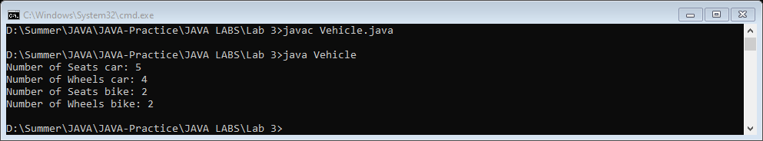

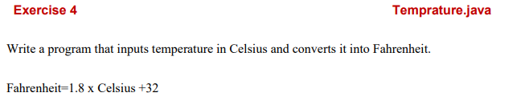

import java.util.Scanner;

class Temperature {

    public static void main(String args[])

    {

        Scanner input = new Scanner(System.in);

        System.out.print("Enter temperature in Celsius: ");

        float temp = input.nextFloat();

        float Fahrenheit = (1.8f * temp) +32f;

        System.out.println("Temperature in Fahrenheit is: "+Fahrenheit);

    }

}

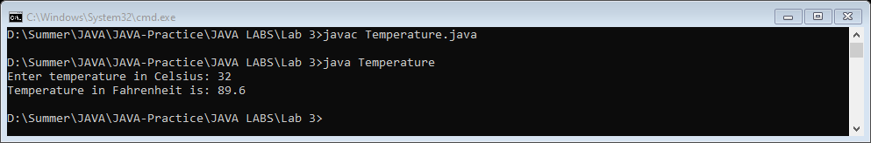

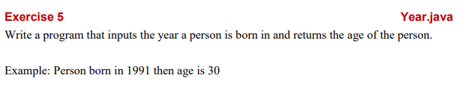

import java.util.Scanner;

class PersonAge {

    public static void main(String args[])

    {

        Scanner input = new Scanner(System.in);

        System.out.print("Enter your born year: ");

        int year = input.nextInt();

        int Year = 2021 - year;

        System.out.println("Person born in "+year+"then age is "+Year+".");

    }

}

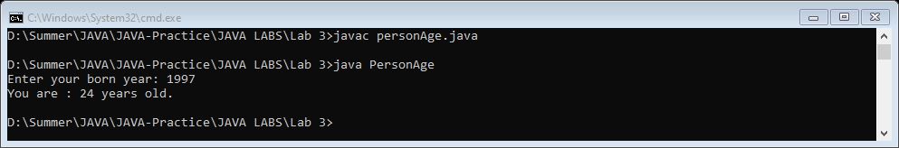

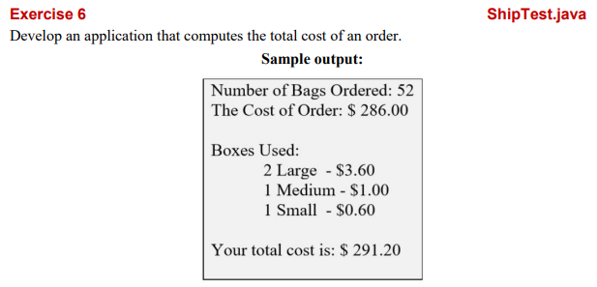

import java.util.Scanner;

class TotalCost {

    public static void main(String args[])

    {

        Scanner input = new Scanner(System.in);

        System.out.print("Enter no of Large Boxes: ");

        int large = input.nextInt();

        System.out.print("Enter no of Medium Boxes: ");

        int medium = input.nextInt();

        System.out.print("Enter no of Small Boxes: ");

        int small = input.nextInt();

        int count = large + medium + small;

        float large_cost = 3.6f * large;

        float medium_cost = 1 * medium;

        float small_cost = 0.6f * small;

        float totalCost = large_cost + medium_cost + small_cost;

        System.out.println("\n\nNumber of Bags Ordered: "+count);

        System.out.println("The cost of Order: $"+totalCost);

    }

}

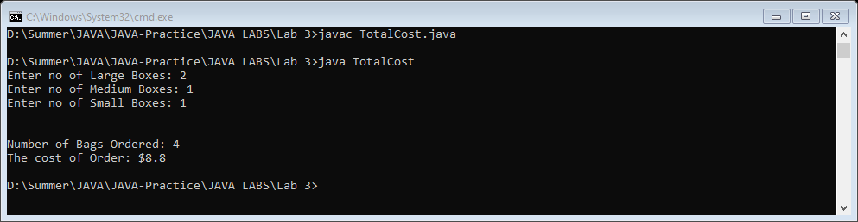

**1. Can constructors be private?**

Yes, we can declare a constructor as private. If we declare a constructor as private we are not able to create an object of a class.

**2. Can a non-static method access a static variable or call a static method?**

Non-static methods can access any static method and static variable also, without using the object of the class.

**3. State differences between java constructor and java methods?**

Following are the difference between constructor and method.

* Constructor is used to initialize an object whereas method is used to exhibits functionality of an object.
* Constructors are invoked implicitly whereas methods are invoked explicitly.
* Constructor does not return any value where the method may/may not return a value.
* In case constructor is not present, a default constructor is provided by java compiler. In the case of a method, no default method is provided.
* Constructor should be of the same name as that of class. Method name should not be of the same name as that of class.

**End of Lab 3**